Basic Principles of Epidemiology: 573a

Homework 3: Outbreak Investigation

Purpose: to introduce you to a practical application of epidemiology, demonstrate the procedures used in the investigation of an outbreak, and practice some simple calculations

Lectures Modules referenced: Frequency Measures (9-11), Measures of Association (12-14)

Key Concepts: attack rate, relative attack rate, epidemic curve

An Outbreak of Enteritis During a Pilgrimage to Mecca

Analysis of an Epidemic

This exercise is a case study of an outbreak of enteritis during a pilgrimage to Mecca. After reading this case study and answering all 16 embedded questions, a student will be able to do the following:

- Define an epidemic, an outbreak, and a cluster
- Create and understand the uses of a case definition
- Draw and epidemic curve
- Calculate food-specific attack rates
- List the steps in investigating an acute outbreak

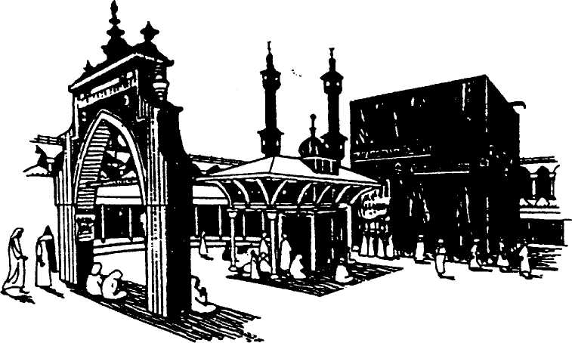
FIGURE 1 Illustration of the Kaaba in Mecca

AN OUTBREAK OF ENTERITIS DURING A PILGRIMAGE TO MECCA

Part I

On the morning of November 1, 1979, during a pilgrimage to Mecca, the epidemiologist assigned to the Kuwaiti medical mission experienced acute onset of abdominal cramps and diarrhea at the holy mosque before the walk around the Kaaba. He subsequently learned that other members of the mission had developed similar symptoms. When he returned that evening to Muna, he initiated an investigation.

- What information do you need to decide if this is an epidemic?
One would need to know the incidence of the disease in the general population and the incidence of the disease in Mecca.

The epidemiologist interviewed several ill members of the mission to better characterize the illness. On the basis of these interviews, the epidemiologist quickly prepared a questionnaire and conducted interviews with the 112 members of the Kuwaiti medical mission.

A total of 66 cases of illness were identified; 2 had onset in Kuwait prior to the beginning of the pilgrimage and 64 had onset of symptoms beginning late in the afternoon on October 31.

- Is this an epidemic? Explain your answer.
There is insufficient evidence to determine whether this is an epidemic since only those in the mission were interviewed. If we define the population as only those on the mission and we define exposure as being in Mecca then we have:
R_e=66/112=0.59 and R_u=2/112= , the Relative Risk =66/2=33

The RR appears to be substantial for those exposed to Mecca.

Description of the Pilgrimage

The Kuwaiti medical-mission, consisting of 112 members, traveled by automobile from Kuwait to Mecca. On October 30 all members of the mission slept in Muna. At sunrise on October 31 they traveled to Arafat, where at 8:00 a.m. they had tea with or without milk for breakfast. The milk was prepared immediately before consumption by mixing powdered milk with boiled water. The remainder of the day was devoted to religious services. At 2:00 p.m., a lunch was served for all members of the mission who wished to partake. It was a typical Kuwaiti meal consisting of three dishes: rice, meat, and tomato sauce. Most individuals consumed all three dishes. The lunch had been prepared in Muna on October 30 and transported to Arafat by truck early on October 31. At sunset on October 31 the mission members returned to Muna.

Clinical Description

The investigator identified a total of 66 cases of gastroenteritis. The onset of all cases was acute, characterized chiefly by diarrhea and abdominal pain. Nausea, vomiting, and blood in the stool occurred infrequently. No case-patient reported fever. All recovered within 12 to 24 hours. Approximately 20% of the ill individuals sought medical advice. The investigator did not obtain any fecal specimens for examination.

- Develop a preliminary case definition.
I would define a case as the acute onset of diarrhea and abdominal pain with symptoms lasting less than 24 hours.

- List the broad categories of diseases that must be considered in the differential diagnosis of an outbreak of gastrointestinal illness.

Note: These concepts have not been covered in this course. Take a look at Major Causes of Acute Diarrhea. (If this link doesn’t work, the file can be accessed through Day05 in the homework section).
In order to differentiate GI illness we would need information on: bloody stools, cramps, diarrhea, fever, headache, nausea, and vomiting.

- What clinical and epidemiologic information might be helpful in determining the etiologic agent(s)?
Certainly the clinical information listed above would help characterize the disease and, therefore, identify the most likely pathogen (or class of pathogen). This, combined with information on the typical disease progression, could provide information on the most likely source of infection. Additional epidemiological information about exposure differences between the individuals who exhibited the disease and those that didn’t would also help.

- The Kuwaiti investigators distributed a questionnaire to ail members of the mission. What information would you solicit on this questionnaire?
In addition to the information collected by the epidemiologist referenced above I would collect dietary information from travelers for the previous 48 hours prior to symptom onset (72 hours would be better but this may be difficult to detect).

Part II

Investigators determined that of the 64 cases with onset during the pilgrimage, all had eaten lunch in Arafat at 2:00 p.m. on October 31. Fifteen members of the mission did not eat lunch; none of these became ill.

- Calculate the attack rate for those who ate lunch and those who did not. What do you conclude?
Attack rate for lunch eaters: 64/112=0.57 attacks/person (assuming the 2 individuals who contracted the illness prior to the mission were at-risk)
Attack rate for abstainers : 0

Table 1 presents some of the information collected by the investigators. The two members who developed illness prior to October 31 have been excluded. The 15 members of the mission who did not eat lunch are not included in Table 1.

- Using appropriate time periods, draw an epidemic curve. [Note: the x-axis will be dates and times, the y-axis will be #s of cases falling ill at that time].
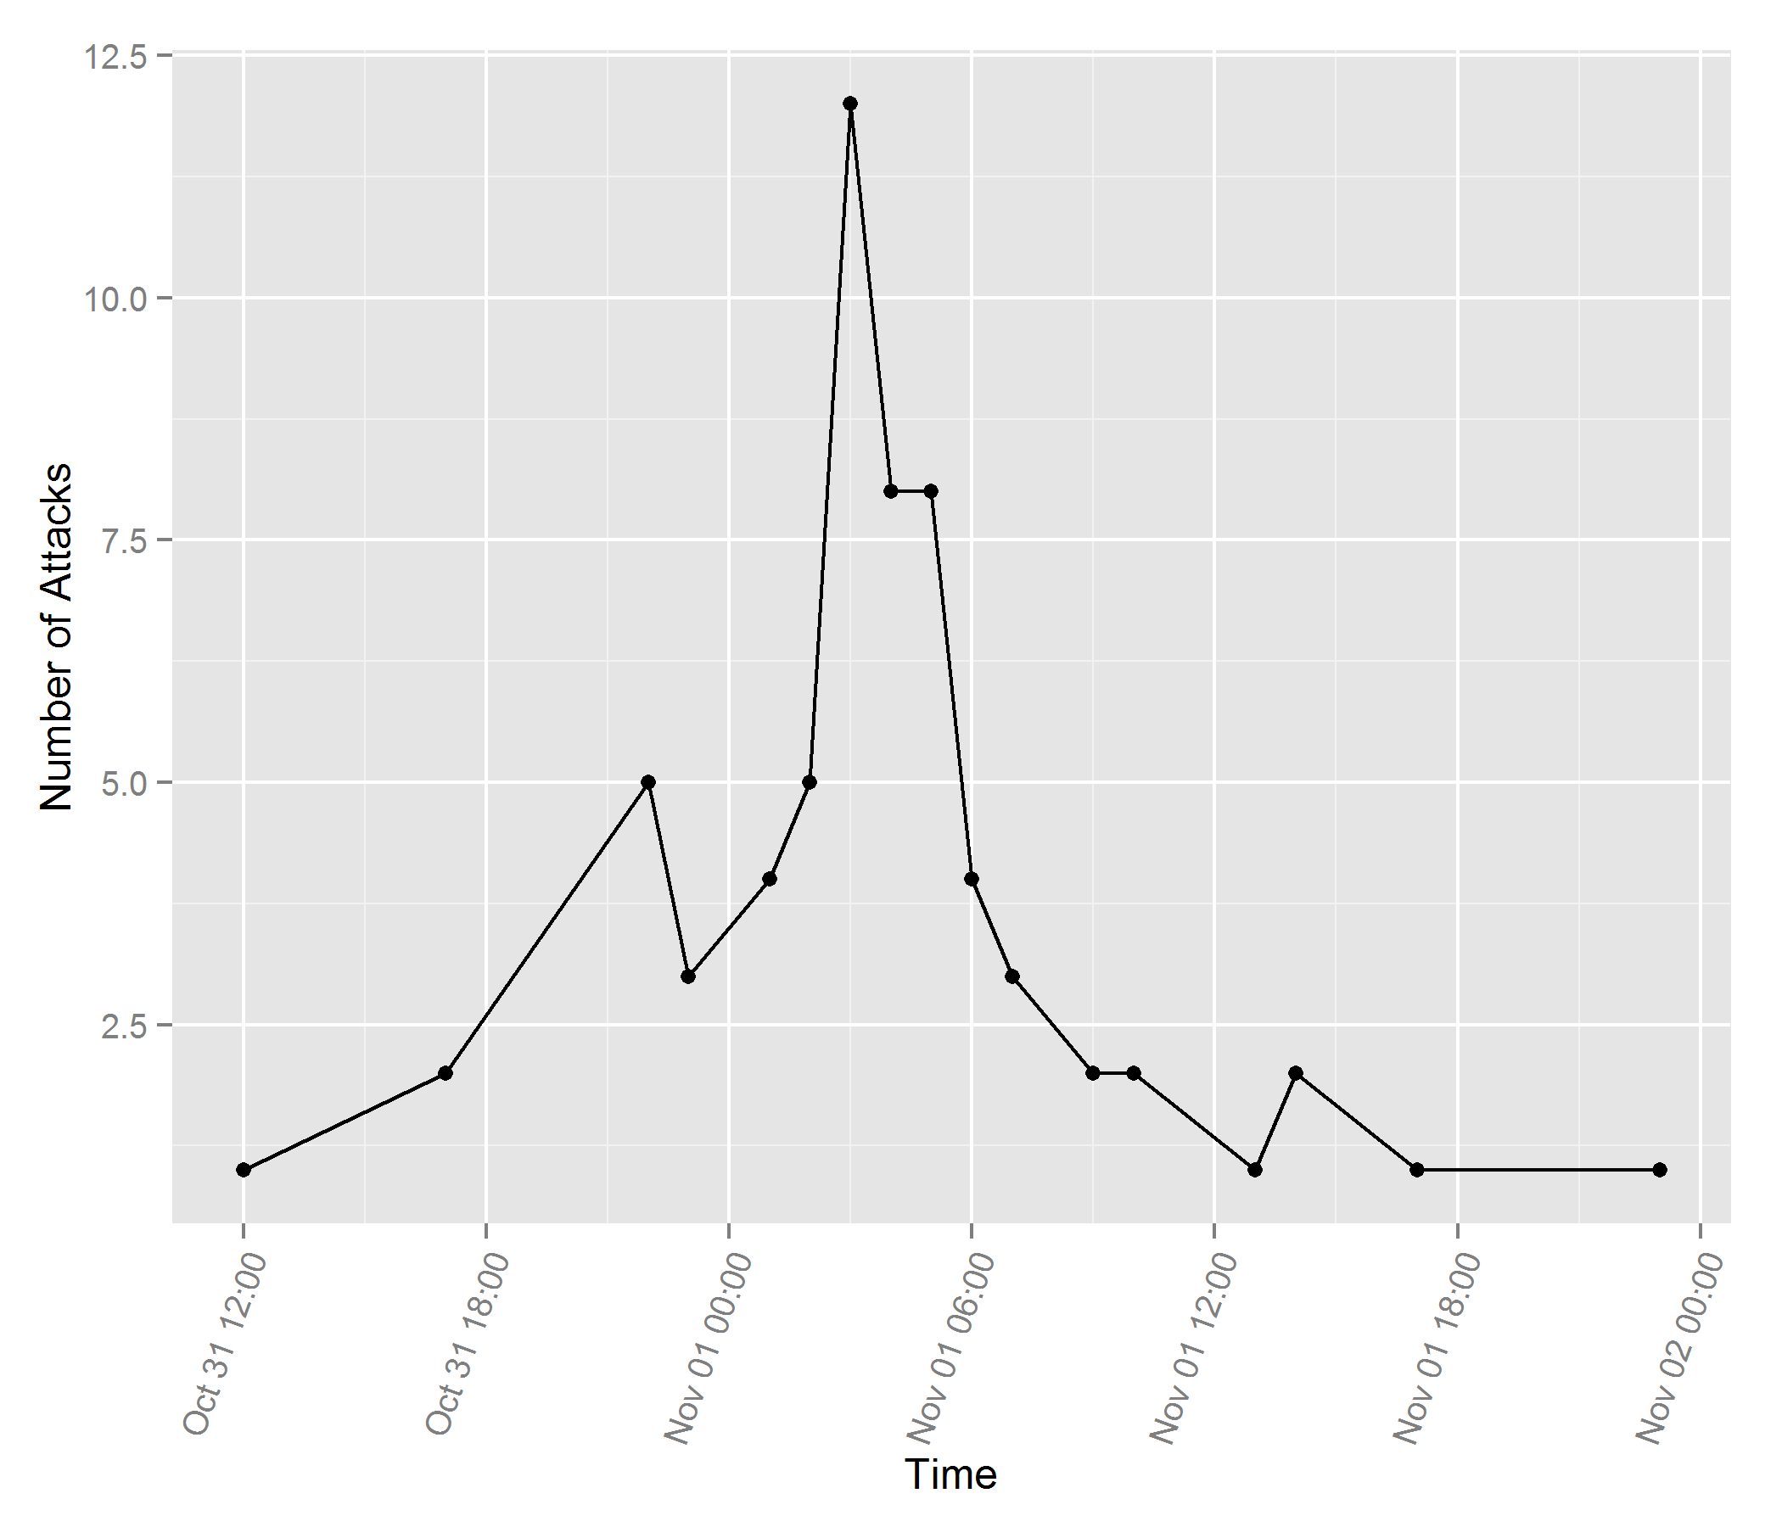

- Are there any cases for which the time of onset seems inconsistent? How might they be explained?
The distribution of attacks looks pretty normal to me centered at 11/1/2015 at 3 am. However, there does appear to be a small peak about 4 hours earlier and a longer right tail than we might expect. Many of the disease incubation periods can vary by several days, which could explain the longer right tail. Also, since the majority of attacks occurred in the night there may have been some that observed symptom before they went to bed while others did not observe symptoms until they became more severe and woke them up.

- Modify the graph you have drawn (Question 8) to illustrate the distribution of incubation periods. [Note: now the x-axis will be hours since the lunch, the y-axis will still be #s of cases falling ill at that time].
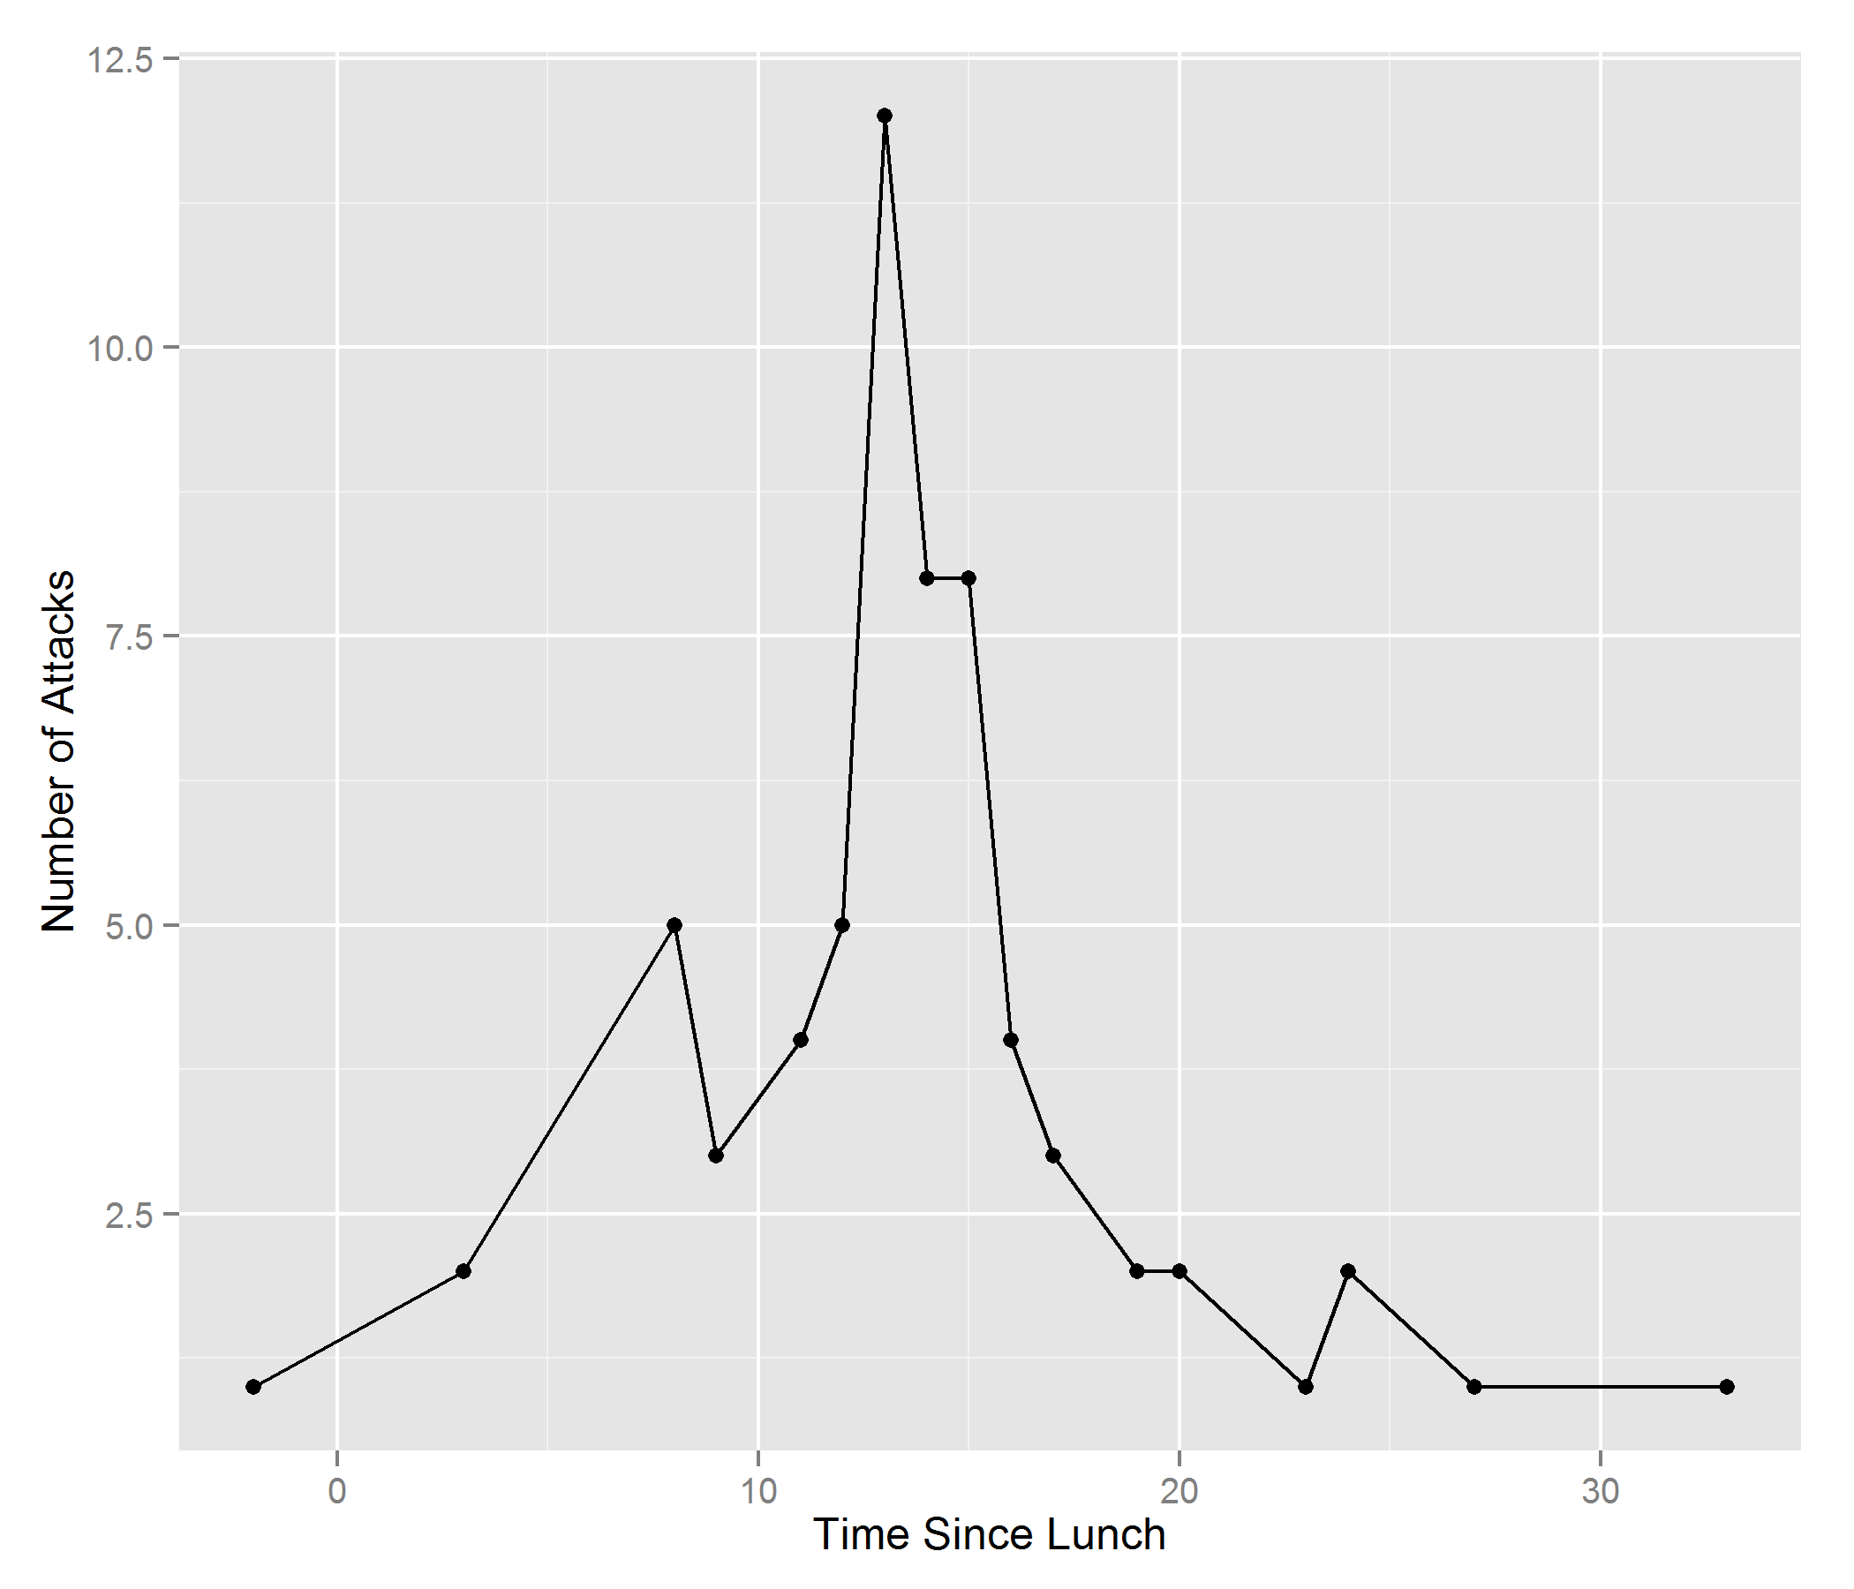

- Calculate the minimum, maximum, mean, median, mode, range, and standard deviation of the incubation periods.

[Each of these measures can be gotten from any list of numbers in any data-oriented software. If you have a list of #s in excel you can just ask excel for the mean, median, mode, range, and standard deviation.
You type:
=average(A#..A# )
=median(A#..A# )
=mode(A#..A#)
=min(A#..A#)
=max(A#..A#)
=stdev(A#..A#)
where A#..A# is the range of cells that contain the numbers for which you want the standard deviation. The range can then be determined by subtracting the min from the max.
For standard deviation, in this course it is necessary only that you remember that this is an indication of how spread out the values in your list are.]

Min. 1st Qu. Median Mean 3rd Qu. Max.
-2.00 11.00 15.00 15.41 20.00 33.00
Std. Dev.: 8.6751
Range: 35
Mode: 13

- Calculate the frequency of each clinical symptom among the cases.

D | C | BS | N | V | F
62 | 52 | 8 | 0 | 2 | 0

- How does the information on the symptoms and incubation periods help you to narrow the differential diagnosis? (You may refer to the attached "Abbreviated Compendium of Acute Foodborne Gastrointestinal Diseases" in Appendix 0.)
Bacillus cerus has an appropriate incubation period and is typified by diarrhea and cramps but no bloody stool. Vibrio parahaemolyticus also has an appropriate incubation time but has many more symptoms which did not manifest. Another likely candidate is Clostridium perfringes but, again, bloody stool is not on the symptom list.

- Using the food consumption histories in Table 1, complete the following table:

 |  | Those who ATE the food item |  |  |  |  |  |  |  | Those who did NOT EAT the food item
Food Item |  | Ill |  | Not Ill |  | Total |  | Percent Ill |  | Ill |  | Not Ill |  | Total |  |  |  | Percent Ill
Rice |  | 62 |  | 31 |  | 93 |  | 66.7 |  | 2 |  | 0 |  | 2 |  | 100
Meat |  | 63 |  | 25 |  | 88 |  | 71.6 |  | 1 |  | 6 |  | 7 |  | 14.3
Tomato Sauce |  | 50 |  | 26 |  | 76 |  | 65.8 |  | 14 |  | 5 |  | 19 |  | 73.7

- Do these calculations help you to determine which food(s) served at the lunch may have been responsible for the outbreak?
Yes, only meat has a higher percentage of ill consumers than ill abstainers.

- Now divide the Percent Ill among those who ATE each food item by the Percent Ill among those who did NOT EAT that food item:

Rice: .667
Meat: 5.0
Tomato Sauce: 0.89

- Does this calculation help you determine which food(s) may have been responsible?
Yes, this simply summarizes the information in the original table so that it is clear that the odds of getting ill is substantially greater for those who ate meat.

- Outline further investigations which should be pursued. List one or more factors that could have led to the contamination of the implicated food.
One could test if the observed increase is risk attributable to meat is greater than one would expect by chance (i.e. test for statistical significance). A sample of the meat could be investigated for a pathogen.

Part III

The lunch which was served in Arafat at 2:00 pm. on October 31 was prepared at 10:00 p .M. the night before in Muna. It consisted of boiled rice, chunks of Iamb fried in oil, and tomato sauce prepared from fresh tomatoes which were sectioned and stewed. The cooked rice was placed in two large pots and the lamb was divided evenly on top. The tomato sauce was kept in a third pot.

These pots were covered with metal tops and placed in an open spot among some to& near the kitchen and allowed to stand overnight. They were presumably not touched by anyone during this period. Early in the morning on October 31, the pots were transported by truck from Muna to Arafat where they stood in the truck until 2:00 pm. The temperature in Arafat at noon that day was 35 °C. The food was not refrigerated from the time of preparation to the time of consumption.

Cooks and all other individuals who helped in preparing the meal were intensively interviewed regarding any illness present before or at the time of preparation. All individuals interviewed denied having any illness and knew of no illness among other members of the group responsible for meal preparation. No specimens were obtained from any of the cooks for laboratory examination.

The following is quoted verbatim from the report prepared by the epidemiologist who investigated the outbreak:

This clinical picture probably suggests an infection by Clostridium porringers. This organism could be detected in the food elements consumed as well as in the patient's stool. However, no laboratory diagnostic procedures were possible in the outbreak site. All the investigations conducted were based entirely on epidemiologic grounds.

The incubation period as well as other data extrapolated from epidemiological analysis suggests that Clostridium porringers is the causative agent. This organism is widely distributed in nature especially in soil and dust. So there is ample opportunity for contamination of the food. If cooked meat is allowed to cool slowly under suitable anaerobic conditions, spores which might have survived cooking or have subsequently come from dust nay germinate and within a few hours produce large numbers of vegetative bacilli. In fact, the pilgrimage camp in Muna lacks sanitary cooking facilities. The food is usually prepared in a dusty place open to the blowing winds creating an ideal situation for Clostridium porringers contamination.

The type of the organism, the type of food dish it usually contaminates, its mode of spread and the differences in the attack rates for those who consumed meat and those who did not points to the meat as the probable source of infection in this outbreak.

Conclusion: The acute illness of enteritis in Arafat affected many persons in an epidemic form; it was a common-source outbreak, the source being the meat consumed at the Arafat lunch. The incubation period was about 13 hours. The illness was characterized by colicky abdominal pain and diarrhea with no elevation of temperature. The responsible agent for this outbreak is most probably Clostridium perfringes. The lunch at Arafat should have been prepared in the same day of consumption, or kept refrigerated if it had to be prepared the day before. Although kitchens could not be fully equipped to fulfill the essential safely measures in a place like Muna, they should be supplied by essential measures to protect food from contamination. The remaining food in Arafat should have been condemned after the investigation, but none remained at that time.

The epidemiological investigations carried out in this epidemic could explore the nature of this epidemic and answer most of the questions raised. The laboratory investigation, although helpful to detect the causative organisms, should not replace the more efficient epidemiological methods in the exploration of such epidemics. The lack of the necessary laboratory facilities to detect the causative organisms in foodborne outbreaks should not discourage the investigative epidemiologist and make him doubtful and lose confidence in his epidemiological tools.

- In the context of this outbreak, what control measures would you recommend?
I would recommend eating food immediately after cooking or, if this is not possible, only consuming cured foods with low risk of infection.

- Was it important to work up this outbreak?
Yes, it is important to understand the causes of these outbreaks in order to prevent future occurences even though all those affected were asymptomatic after a short time.
TABLE 1. Selected characteristics of Kuwaiti medical mission members who ate lunch at Arafat, Saudi Arabia, October 31, 1979

 |  |  | Onset of Illness |  |  | Foods |  |  |  | Signs / Symptoms
ID# | Age | Sex | Date | Hour |  | Rice | Meat | TS |  | D | C | BS | N | V | F
31 | 36 | M | Oct 31 | 5:00 PM |  | x | x | x |  | D | C | BS
77 | 28 | M | Oct 31 | 5:00 PM |  | x | x |  |  | D | C
81 | 33 | M | Oct 31 | 10:00 PM |  | x | x | x |  | D | C
86 | 29 | M | Oct 31 | 10:00 PM |  | x | x | x |  | D | C
15 | 38 | M | Oct 31 | 10:00 PM |  |  | x |  |  | D |  | BS
17 | 48 | M | Oct 31 | 10:00 PM |  | x | x |  |  | D | C
18 | 35 | M | Oct 31 | 10:00 PM |  | x | x | x |  | D | C
35 | 30 | M | Oct 31 | 11:00 PM |  | x | x | x |  | D | C
88 | 27 | M | Oct 31 | 11:00 PM |  | x | x | x |  | D | C
76 | 29 | M | Oct 31 | 11:00 PM |  | x | x | x |  | D | C | BS
71 | 50 | M | Oct 31 | 12 Mid |  | x | x | x |  | D
1 | 39 | F | Nov 1 | 1:00 AM |  | x | x | x |  | D | C |  |  | V
27 | 36 | M | Nov 1 | 1:00 AM |  | x | x | x |  | D | C
28 | 44 | M | Nov 1 | 1:00 AM |  | x | x | x |  | D | C
29 | 48 | M | Nov 1 | 1:00 AM |  | x | x | x |  | D | C | BS
30 | 35 | M | Nov 1 | 2:00 AM |  | x | x | x |  | D | C
50 | 29 | M | Nov 1 | 2:00 AM |  | x | x | x |  | D | C
59 | 51 | M | Nov 1 | 2:00 AM |  | x | x | x |  | D | C
67 | 40 | M | Nov 1 | 2:00 AM |  | x | x |  |  | D
72 | 58 | M | Nov 1 | 2:00 AM |  | x | x | x |  | D | C
73 | 28 | M | Nov 1 | 3:00 AM |  | x | x | x |  | D | C
60 | 31 | M | Nov 1 | 3:00 AM |  | x | x | x |  | D | C
61 | 28 | M | Nov 1 | 3:00 AM |  | x | x | x |  | D |  | BS
51 | 32 | M | Nov 1 | 3:00 AM |  | x | x | x |  | D | C |  |  | V
52 | 37 | M | Nov 1 | 3:00 AM |  | x | x |  |  | D
58 | 30 | M | Nov 1 | 3:00 AM |  | x | x | x |  | D | C
22 | 30 | M | Nov 1 | 3:00 AM |  | x | x | x |  | D | C
25 | 30 | M | Nov 1 | 3:00 AM |  | x | x |  |  | D | C
32 | 50 | M | Nov 1 | 3:00 AM |  | x | x | x |  | D | C
28 | 26 | M | Nov 1 | 3:00 AM |  | x | x | x |  | D | C
79 | 29 | M | Nov 1 | 3:00 AM |  | x | x | x |  | D | C
80 | 28 | M | Nov 1 | 3:00 AM |  | x | x | x |  | D | C
37 | 30 | M | Nov 1 | 4:00 AM |  | x | x | x |  | D |  | BS
65 | 34 | M | Nov 1 | 4:00 AM |  | x | x |  |  | D
66 | 45 | M | Nov 1 | 4:00 AM |  | x | x |  |  | D | C
87 | 41 | M | Nov 1 | 4:00 AM |  | x | x | x |  | D | C
89 | 43 | M | Nov 1 | 4:00 AM |  | x | x | x |  | D | C
90 | 43 | M | Nov 1 | 4:00 AM |  | x | x | x |  | D | C
91 | 38 | M | Nov 1 | 4:00 AM |  | x | x | x |  | D | C
92 | 37 | M | Nov 1 | 4:00 AM |  | x | x | x |  | D | C
70 | 31 | M | Nov 1 | 5:00 AM |  | x | x | x |  | D | C
2 | 34 | F | Nov 1 | 5:00 AM |  | x | x | x |  | D | C
21 | 38 | M | Nov 1 | 5:00 AM |  | x | x | x |  | D | C
40 | 36 | M | Nov 1 | 5:00 AM |  | x | x | x |  | D
78 | 27 | M | Nov 1 | 5:00 AM |  | x | x | x |  | D | C
82 | 39 | M | Nov 1 | 5:00 AM |  | x | x | x |  | D | C
83 | 40 | M | Nov 1 | 5:00 AM |  | x | x | x |  | D | C
84 | 34 | M | Nov 1 | 5:00 AM |  | x | x |  |  | D | C
14 | 52 | M | Nov 1 | 6:00 AM |  | x | x | x |  | D
16 | 40 | M | Nov 1 | 6:00 AM |  | x | x | x |  | D |  | BS
93 | 30 | M | Nov 1 | 6:00 AM |  | x | x | x |  | D | C
94 | 39 | M | Nov 1 | 6:00 AM |  | x | x | x |  | D | C
33 | 55 | M | Nov 1 | 7:00 AM |  | x | x | x |  | D | C
34 | 28 | M | Nov 1 | 7:00 AM |  | x | x | x |  | D | C
85 | 38 | M | Nov 1 | 7:00 AM |  | x | x |  |  | D | C
43 | 38 | M | Nov 1 | 9:00 AM |  | x | x |  |  | D | C
69 | 30 | M | Nov 1 | 9:00 AM |  | x | x | x |  | D | C
4 | 30 | F | Nov 1 | 10:00 AM |  | x |  |  |  | D | C
5 | 45 | F | Nov 1 | 10:00 AM |  |  | x |  |  |  | C
3 | 29 | F | Nov 1 | 1:00 PM |  | x | x |  |  | D | C
12 | 22 | F | Nov 1 | 2:00 PM |  | x | x | x |  |  | C
74 | 44 | M | Nov 1 | 2:00 PM |  | x | x | x |  | D
75 | 45 | M | Nov 1 | 5:00 PM |  | x | x | x |  | D |  | BS
95 | 40 | M | Nov 1 | 11:00 PM |  | x | x | x |  | D | C
6 | 38 | F | Well |  |  | x | x
7 | 52 | F | Well |  |  | x | x | x
8 | 35 | F | Well |  |  | x |  | x
9 | 27 | F | Well |  |  | x | x | x
10 | 40 | F | Well |  |  | x | x | x
11 | 40 | F | Well |  |  | x | x | x
13 | 50 | M | Well |  |  | x | x | x
19 | 38 | M | Well |  |  | x | x | x
20 | 38 | M | Well |  |  | x | x | x
23 | 29 | M | Well |  |  | x | x | x
24 | 27 | M | Well |  |  | x | x | x
26 | 47 | M | Well |  |  | x | x | x
36 | 60 | M | Well |  |  | x
39 | 27 | M | Well |  |  | x | x | x
41 | 30 | M | Well |  |  | x | x | x
42 | 38 | M | Well |  |  | x | x | x
44 | 50 | M | Well |  |  | x | x | x
45 | 27 | M | Well |  |  | x | x | x
46 | 31 | M | Well |  |  | x | x | x
47 | 46 | M | Well |  |  | x | x | x
48 | 38 | M | Well |  |  | x | x
49 | 36 | M | Well |  |  | x |  | x
53 | 36 | M | Well |  |  | x | x | x
54 | 27 | M | Well |  |  | x | x | x
55 | 40 | M | Well |  |  | x | x | x
56 | 30 | M | Well |  |  | x | x | x
57 | 22 | M | Well |  |  | x | x | x
62 | 50 | M | Well |  |  | x
63 | 44 | M | Well |  |  | x
64 | 47 | M | Well |  |  | x |  | x
68 | 31 | M | Well |  |  | x | x | x

from Centers for Disease Control and Prevention: Principles of Epidemiology An Introduction to Applied Epidemiology and Biostatistics (pp. 3I7-413). Atlanta, GA: 1992.
  TS = Tomato sauce; D = diarrhea; C = cramps; BS = blood in stool; N = nausea; V = Vomiting; F = fever Source CDC, 1992

